

Fruit

Image

Data

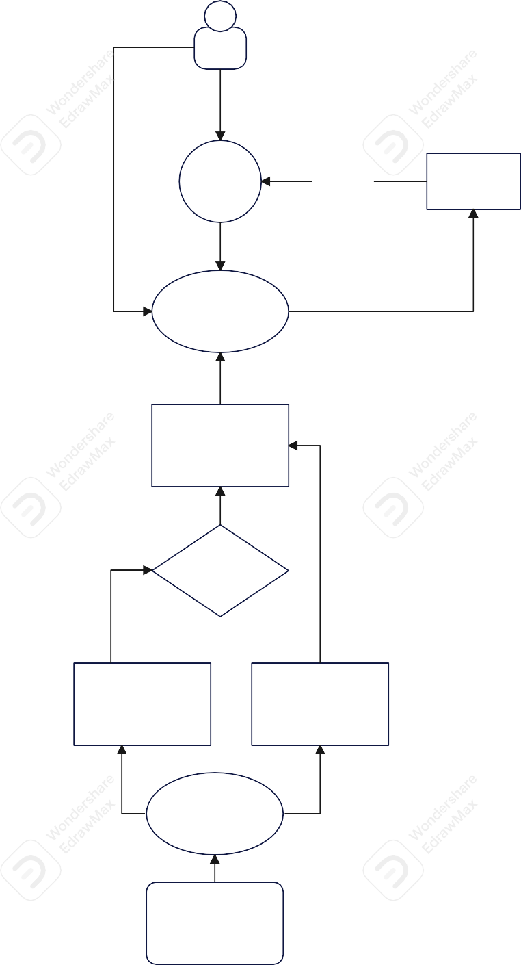

user

UI

Output

Prediction

INPUT

CNN Model

Evaluation

DL

Algorithm

Training set

Testing set

Data

Preprocessing

